CSBE/ SCGAB ANNUAL REPORT, 2020

Annual Report Content
- 2020 AGM Agenda p 2-4
- 2019 AGM Minutes p 5-6
- 2020 Treasures Report p 7
- 2020-2021 CSBE/SCGAB Budget p 8-10
- Council Member Reports p 10-12
- 2020 CSBE/SCGAB Student Awards p 13-15
- 2020 Member Awards p 15 -

THE ANNUAL GENERAL MEETING OF
The Canadian Society for Bioengineering
La Société Canadienne de Génie Agroalimentaire et de Bioingénierie
Date: Tuesday July 21, 2020, Time: Noon Alberta Time

Greetings and attendance sign up
Call to order by CSBE-SGGAB President Agnew
Appointment of Chair and Secretary for meeting
Notice of the Meeting (Notice of Meeting requirement is 14 days)
Quorum (Twenty-five members including at least 5 Council members)

AGENDA
Additions to the Agenda – Guest Speaker – Dr. Tim Geary, a colleague and friend of Chandra, is a parasitologist by training, was Director of the Institute of Parasitology at McGill, and has a good knowledge of the ag/livestock sector. He was a Canada Research Chair, and highly accomplished (https://www.mcgill.ca/parasitology/faculty/geary).
Approval of the Agenda
Approval of Minutes of Previous Meeting (July 15, 2019 – UBC) - see below
Correspondence
Approval of 2020 Council Member Annual Reports – see below
Old Business

New Business
- Introduction of Council Members
CSBE/SCGAB Council for the 2020-2021 year is as follows:
 | Position |  | Current |  | Term length | Term start |  | Term End
 | President-Elect |  | Ying Chen |  | 1 | 2020 |  | 2021
 | President |  | Chandra Madramootoo |  | 1 | 2020 |  | 2021
 | Past President |  | Joy Agnew |  | 1 | 2020 |  | 2021
 | Past-Past President |  | Danny Mann |  | 1 | 2020 |  | 2021
 | VP Technical |  | Jan Adamowski |  | 2 | 2020 |  | 2022
 | VP Regional |  | Amit Kumar |  | 2 | 2019 |  | 2021
 | VP Membership |  | Chelladurai Vellaichamy |  | 2 | 2020 |  | 2022
 | VP Industry |  | Eric Ouellette |  | 2 | 2019 |  | 2021
 | Regional Director Atlantic |  | Travis Esau |  | 2 | 2019 |  | 2021
 | Regional Director QC |  | Stephane Godbout |  | 1 | 2020 |  | 2021
 | Regional Director ON |  | Ashutosh Singh |  | 2 | 2020 |  | 2022
 | Regional Director MB |  | Fuji Jian |  | 2 | 2019 |  | 2021
 | Regional Director SK |  | Sarah Yeo |  | 2 | 2019 |  | 2021
 | Regional Director AB |  | Israel Dunmade |  | 1 | 2020 |  | 2021
 | Regional Director BC |  | Keith Duhaime |  | 2 | 2020 |  | 2022
Appointed Council Members or Representatives
Society Manager |  | John Feddes |  | 5 |  |  | 2013 |  | 2021
Treasurer |  | Franklin Kains |  | 3 |  |  | 2017 |  | 2020
Web Master |  | Rene Morissette |  | 3 |  |  | 2008 |  | 2020
Managing Editor |  | Ramanathan Sri Ranjan |  | 3 |  |  | 2012 |  | 2021
Journal Editor |  | Manokararajah Krishnapillai
EIC Rep |  | Chandra Madramootoo or his appointee |  | 1 |  |  | 2020 |  | 2021
CIGR Rep |  | Stephane Godbout |  | 3 |  |  | 2017 |  | 2020

Council Members Retiring:
Vijaya Raghavan (Past-Past President)
Bernard Goyette (VP Membership)
Regional Director BC (Fahimeh Yazdan Panah)

Council Members Remaining for Additional Term:
Jan Adamowski (VP Technical)
Ashutosh Singh (Regional Director Ontario) (2 yr)
Stephane Godbout (Regional Director Quebec) (1 yr extension only)
Israel Dunmade (Regional Director Alberta) (1 yr extension only)

New Council Members:
Ying Chen (President-Elect)
Chelladurai Vellaichamy (VP Membership)
Keith Duhaime (Regional Director BC)

- Approval of 2020-2021 budget – see below
- Approval of Bylaws – see below
- Appointment of Auditor (Thornton and Co, Winnipeg) for 2020 Financial Statements
- Appoint Franklin Kains and John Feddes to be the signing authorities until the next Annual meeting

Announcements
- Student Awards – see below
- Grade of Fellow - Member Awards - see below
- Introduce “Social Media Manager” – Prasad Daggupati
- CSBE/SCGAB Expertise Database
- CSBE/SCGAB Foundation

Closing Remarks – President Agnew
Adjournment

Minutes of the Annual General Meeting of Members of

The Canadian Society for Bioengineering
La Société Canadienne de Génie Agroalimentaire et de Bioingénierie

Held Monday July 15, 2019 - Time: 1230 to 1330 at the University of British Columbia

Call to order (President Mann)
Attendance sheets circulated and signed by membership
CHAIRMAN AND SECRETARY OF THE MEETING
Upon motion made (Prasher) and duly seconded (Ranjan), it was unanimously resolved to appoint President Mann and Society Manager Feddes as chairman and secretary of the meeting, respectively. Approved.

Notice of meeting
The Notice of Meeting requirement (14 days) was met.
QUORUM (Twenty-five members including at least 5 officers of Council)
The quorum requirements were met.

Additions to the agenda
- no additions

APPROVAL OF AGENDA
Upon motion made (Raghavan) and duly seconded (Predicala) the agenda was approved.
Approval of minutes of previous meeting 2018 07 23
Upon motion made (Jayas) and duly seconded (Godbout), it was unanimously resolved to accept the minutes as distributed. Approved.
Correspondence
-none

ANNUAL Report
An Annual Report document (compilation of Council members Annual reports) was emailed to every member prior to the AGM. The Annual Report included the Agenda, 2018 AGM minutes , the proposed 2020 Budget and Statement of Revenues, Expenditures and Holdings. Upon motion made (Jian) and duly seconded (Godbout), it was unanimously resolved to accept the Annual Report as distributed. Approved.

Unfinished business
-none

New business
- Past President Raghavan moved that nominations cease. Approved. He introduced the New Council members. Chandra Madramootoo (President Elect), Joy Agnew (President); Danny Mann (Past President), Amit Kumar (VP Regional), Eric Ouellette (VP Industry), Fuji Jian (Regional Director MB), Sarah Yeo (Regional Director SK). The members of the Awards, Fellows, and Nominating committee are listed in the Annual report.
- The budget for 2020 was included in the Annual Report and presented by Society Manager John Feddes. Upon motion made (Morgan) and duly seconded (Predicala), it was unanimously resolved to accept the 2020 budget as distributed. Approved.
- Appointment of Auditor for 2019 Financial Statements. Upon motion made (Ranjan) and duly seconded (Morgan), it was unanimously resolved to reappoint Thornton & Co. as auditors for the 2019 financial activities. Approved.
- There were no Bylaw changes. The 2018 Bylaws are now listed as the 2019 Bylaws
- Upon motion made (Agnew) and duly seconded (Jayas), it was unanimously resolved that Franklin Kains and John Feddes be the signing authorities until the 2020 Annual Meeting. Approved.

ANNOUNCEMENTS

- Seeking “Social Media Manager” to be responsible for working with the various media platforms
- Seeking “Society Manager” for spring 2020
- Volunteers to assist with website translation CSBE/SCGAB Expertise Database – encourage members to complete their profile
- CSBE/SCGAB Foundation
- On behalf of the CSBE/SCGAB FOUNDATION, John Feddes reminded the membership to consider donating to the Foundation. Decided to separate Foundation donations and membership renewal for members who have their fee remunerated by their employer. Will consult with Webmaster. This year the Foundation supported 37 Grad student first year memberships ($2664), 5 Foundation Scholarships ($1500) and ¼ Scale tractor teams (Laval, McGill, and Saskatchewan) $1500. Expenses exceeded Donations. A glossy handout was available to explain the Foundation.
- Greetings from ASABE President Sue Nokes

Adjournment
President Mann, thanked all participants at the AGM, called for adjournment at 1:30 pm. Upon motion made (Agnew) and duly seconded (Prasher), it was unanimously resolved to adjourn. Approved.
Minutes recorded by:
John Feddes
Society Manager, Date of approval: ______________
ATTACHMENTS:
  - Members and visitor attendance list
  - 2019 CSBE-SCGAB Annual Report
  - List of 2018-2019 Council Members

Treasurer’s Report for the 2020 AGM
Franklin Kains, CSBE/SCGAB Treasurer
The following is the treasurer’s report for fiscal 2019 and is based on the year-end audit as completed by Thornton and Co. The expenditures, revenues and budgets are shown in Table 1. The assets are shown in Table 2.
Actuals
The shaded column in Table 1 are the actuals for 2019. The audit shows that for fiscal year 2019, CSBE/SCGAB had a deficiency of revenue over expenses of $3,403 for 2019. This compares to a deficiency of $6,395 for the previous year, 2018. Of note, was a reduction of $4,230 in revenue from memberships for the year.
Projected Budgets
At our July 2018 AGM, we budgeted for a deficiency of $12,900 for fiscal 2019. Thus, the actual deficiency of $3,403 was 73% less than the budget. The budget done last July for 2020 predicted an excess of revenues over expenses of $6,300 for the year. This excess included revenue of $15,000 generated from the CIGR conference in Quebec City which was to be held in June of 2020. This, of course, has been postponed for a year due to the world wide COVID 19 pandemic. This unexpected turn of events will alter both expenditures and revenues for 2020 from what was budgeted last July.
Net Assets
At the end of 2019, net assets stood at $223,731 which includes the BMO operating account, the Nesbitt Burns long term investment account, accounts receivable and prepaid expenses. This is a decrease of $3,135 from the year previous, a decline of just over 1%.
Investments and Cash
The cash accounts at both BMO and Nesbitt Burns were reduced to pay for down payments on various events and items related to the CIGR and CSBE June conference in Quebec City postponed to next May.
The long-term investments at year end were up $12,313 from the year previous reflecting the recovery in the stock market through 2019. Going back 6 years, the net assets stood at $139,885 at the end of fiscal year 2013.

Summary
It would appear that financially CSBE/SCAGB has sufficient cash inflow and savings to prudently carry on for the foreseeable future.
Table 1: 2019 Statement of Revenues, Expenditures and Budgets
 | 2018 Budget | 2018 Actuals | 2019 Budget | 2019 Actuals | 2020 Budget | 2021 Budget
REVENUE
Membership fees | $28,000 | $22,625 | $24,000 | $18,395 | $22,000 | $18,000
Annual Gen Meeting (AGM) | $49,000 | $50,188 | $49,000 | $39,176 | $70,000 | $70,000
Canadian Bio Systems Journal | $14,000 | $7,502 | $10,000 | $9,930 | $8,000 | $8,000
Advertising | 0 | 200 | $500 | $145 | $500 | $500
Expense recoveries (rebates) | $600 | $96 | $0 | $0 | $0 | $0
Investment income | $3,500 | $3,748 | $3,500 | $4,856 | $3,500 | $3,500
Unrealized capital gains | 0 | ($13,134) | $4,000 | $12,311 | $4000 | $4000
Total Revenue | $95,100 | $71,225 | $91,000 | $84,813 | $108,000 | $104,000
EXPENDITURES
Advertising/promotion | - | - | - | $5,775 | $0 | $0
Annual General Meeting (AGM) | $40,000 | $36,245 | $44,000 | $38,215 | $50,000 | $50,000
ASABE board president's discretion | $3,500 | $0 | $3,500 |  | $3,500 | $3,500
CDN Bio systems Journal | $2,600 | $1,067 | $2,000 | $1,556 | $2,000 | $2,000
Journal reviewer’s incentives | $3,000 | $550 | $2,500 | $124 | $2,500 | $2,500
Journal Translation | $600 |  | $600 |  | $600 | $600
CIGR Dues | $1,100 | $1,072 | $1,100 | $1,095 | $1,100 | $1,100
EIC dues, directors’ insurance | $2,200 | $1,474 | $2,200 | $1,059 | $2,200 | $2,200
General and student awards | $5,300 | $4,950 | $5,000 | $8,899 | $5,500 | $5,500
Interest, bank /credit charges | $200 | $253 | $200 | $406 | $250 | $400
CSBE manager honorarium | $12,000 | $12,000 | $12,000 | $12,000 | $12,000 | $12,005
CSBE manager office | $4,200 | $2,184 | $4,000 | $3,716 | $3,750 | $3,750
Professional audit, CRA filing | $1,500 | $1,413 | $2,000 | $1,963 | $2,000 | $2,000
Reg'l membership recruitment | $4,000 | $1,958 | $7,000 | $2,256 | $7,000 | $7,000
Student transportation to AGM | $13,000 | $6,275 | $13,000 | $1,862 | $5,000 | $5,000
Contributions and donations | $0 | $750 | $1,000 | $750 | $1,000 | $1,000
Manager/president travel | $3,000 | $4,418 | $3,000 | $8,397 | $2,500 | $4,000
Web site | $800 | $3,011 | $800 | $143 | $800 | $800
Total Expenditures | $97,000 | $77,620 | $103,900 | $88,216 | $101,700 | $103,355
EXCESS (DEFICIENCY) OF REVENUES OVER EXPENSES | ($1,900) | ($6,395) | ($12,900) | ($3,403) | $6,300 | $645

Table 2. Investment Account at Nesbitt Burns

 | 2017 | 2018 | 2019
Investments at Nesbitt Burns
Cash/short term | $73,881 | $77,629 | $62,203
Fixed income | $18,314 | $16,340 | $11,090
Equities | $89,242 | $78,081 | $95,645
Total | $181,434 | $172,050 | $168,938
Cash at BMO | $42,573 | $39,645 | $22,633
Total of all assets | $224,222 | $211,659 | $191,571

COUNCIL MEMBER REPORTS

Joy Agnew - CSBE/SCGAB President

Past President – Danny Mann

President Elect

René Morissette – Webmaster - webmaster@csbe-scgab.ca

CIGR 2020 and Annual Conference in Quebec City
Lots of efforts were made to organize the CIGR 2020 International Conference at several levels: communication to invite the international engineering community, launch of a complete website for the event, launch of a paper submission and registration platform (Conftool), organize a complete program with distinguished keynote speakers, workshops, discussion panels, and technical tours. We received, reviewed and accept more than 600 submissions However, because of the COVID-19 situation, the event was postponed to May 2021. All our efforts have not been in vain because the program will be maintained in its integrity. As webmaster, I’ve been involved in almost every decision-making and technical activities.

Newsletters and Notices to members
A total of 16 newsletters and notices were sent between July 2019 and June 2020 to a list of about 700 contacts. This includes communication to members related to webinars promotion. I had regular communication with ASABE to update our membership email list.

CBE Journal hosting
The CBE Journal management system has been moved to a new address (https://journal.csbe-scgab.ca) and is now hosted on the same server as the CSBE website. I did the migration and some of the basic system configuration, including the new home page design.

Website statistics report
https://www.csbe-scgab.ca
Between June 2019 and June 2020, CSBE website has generated 13850 sessions with 25000 pages viewed. An average of 1.8 pages per visit with duration of about 1:30 minutes was met. These numbers are a little bit lower compared to last year. This could be explained by the fact that all information about the AGM 2020 was hosted on the CIGR 2020 website (www.cigr2020.ca).
The audience was mainly English (75%), Chinese (10%) and French (6%) from Canada (48%), USA (18 %), China (6%), India (5%), and many other countries (France, South Korea, Brazil, Nigeria, Germany, Iran, Brazil…).
Main traffic came from organic search (51%), followed by direct access (30%), site referral (17%) and social media (3%). The social media share has been slightly improved since a Social Media manager is assigned to the task (Prasad Daggupati).
Main pages/sections viewed were the home page, publications/Canada plan archive, Publications/Journal, Vancouver 2019 portal, career and membership pages.
https://library.csbe-scgab.ca (Publications)
The technical library website has generated about 8000 pages viewed, and 2.3 pages per visit. This portal need to be revamped to an up-to-date platform.
The audience was mainly from Canada (29%), USA (24 %), India (6%), China (4%)
Main traffic came from organic search (40%), followed by direct access (38%), and site referral (21%).
https://experts.csbe-scgab.ca (Expertise database)
For a first year in production, the total members registered on the website is only 21. This is very low as the Society has more than 500 active members. The Expertise database should be more promoted in the Council communications and via social media. Overall, the Expertise portal generated about 330 visits and 920 pages were viewed.
https://journal.csbe-scgab.ca (CBE Journal management system)
No statistic for the moment.
Bernard Goyette -Vice-President (Membership)- It has been a pleasure to serve CSBE/SCGAB as a council member for the last two years. During my first year, there was a concern regarding the retention rate of the students. There was a special program that started in 2016 where the Foundation paid the membership dues for first-time-ever Canadian Graduate Students. The returning rate of the student supported by this program was about 38% in 2016 and is now at around 20%. This program is a good strategy to enroll new members but we have to understand why the retention rate is low.
The CSBE/SCGAB total membership was slowly but constantly declining from 2013 to 2018 with a slight increase in 2019. In 2020, partially due to the pandemic, there was a significant decrease on membership renewals, about 28% decrease for a total of 195 individuals who have not renewed with CSBE/SCGAB. In an effort to encourage them to renew, ASABE did propose to offer a special rate for half a year of membership which was accepted by CSBE/SCGAB Council. During the first week of June, the names of the members who didn’t renew their 2020 membership were sent to the VP-Regional for further follow up.
Year | Total membership | Undergraduate student membership
2013 | 692 | 183
2014 | 689 | 151
2015 | 632 | 137
2016 | 638 | 159
2017 | 583 | 120
2018 | 552 | 98
2019 | 613 | 99
2020 (June) | 441 | 90
Table 1: CSBE 2013-2020 membership data

John Feddes - Society Manager - The duties of the Society Manager include the following:
• Record the minutes of Council meetings and the annual business meeting and distribute the minutes to Council members within one month of the meeting.
• Carry on correspondence for the Society.
• Serve as the office liaison with ASABE office.
• Assist in preparing CSBE awards, commendations and student awards for the Annual meeting
Sent in 41 Grad student Applications (Fist time sponsored by the Foundation)
• Sent out new member certificates
• Pay Society expenses.
• Arrange for preparation of auditors report for AGM.
• Serve as the office liaison with affiliate societies.
• Report election results to Council and the annual business meeting.
• File an annual summary with the Minister of Consumer and Corporate Affairs Canada.
• Preserve all documents of the Society except those assigned to other officers or committees.
• Carry out general secretarial duties including keeping of committee lists, bringing appropriate documents to meetings and correspondence.
• Receive all By-law changes but not responsible for making the changes.
• Publish and supply in quantity the Awards Booklet to the AGM.
• Invoice the authors for page charges
• Arrange the printing and mail the CBE Journal
• Serve as Secretary-Treasurer for the CSBE/SCGAB Foundation
• Send out Foundation donation tax receipts

As you are aware, CSBE-SCGAB Society and CSBE-SCGAB Foundation offer several student awards every year. Please email me for information. Student applicants must be a member of the Society. The Foundation will pay the membership dues for first-time-ever Graduate Students. See Website.

This year, we presented 2 ASABE ¼ Scale Tractor Student Design Foundation Awards - $500/each; 5 Foundation Undergraduate Scholarships - $300/student; 23 Undergraduate Awards - $100 /student; 8 Graduate Thesis Awards (MSc) - $200/student; and 3 Graduate Thesis Awards (PhD) - $200/student. Total $7400;; $2500 Foundation, $4900 Society

2020 CSBE/SCGAB STUDENT AWARDS

ASABE ¼ Scale Tractor Student Design Competition - $500

Design and construction of a four-wheel-drive tractor taking into consideration the rules specified by the American Society of Agricultural and Biological Engineers (ASABE)
Université Laval, Équipe ULtrac – J. Fréchette (Leader), G. Lafond, F. Daigneault, É. Marineau-Bélanger, L. Lampron, S. Le Bouthillier, W. Falcon, A. Voghell, J. Mallet, P. Désautels

McGill University, Mutrac – A. Pille, S. McGuire, L. Diaz-Pappas, I. Karovitch, H. Macek, C. Wells, A. Leak, A.Kujiper, D. John, L. Mescheder, N. Audi, V. T. Paepcke, M. Leclerc
CSBE/SCGAB FOUNDATION Undergraduate Scholarship - $300
Recognizes academic excellence among student members of the Society. The Scholarship is awarded each year to the student member of the Society with the highest GPA in the preceding semester.
University of Manitoba – Eva Kwok
McGill University – Beatrice Reid
Université Laval - Étienne Marineau-Bélanger
University of Prince Edward Island- Sydney Wheatley
Dalhousie University - Spencer Hauser

Graduate Thesis Award (PhD) - $200

University of Alberta, Department of Mechanical Engineering - Maryam Akbari for her thesis entitled “Conversion of Organic Waste to Value-added Products” (Advisor: A. Kumar)

McGill University, Department of Bioresource Engineering - Ward Smith for a thesis entitled “Development of hydrologic processes in the DNDC model to explore beneficial management for reducing nutrient losses from cropping systems.” (Advisor: Z. Qi)
Université Laval - Guoqi Wen for a thesis entitled “Étude des effets de la fertilisation azotée sur les concentrations foliaires en sucres, en acides aminés et en glycoalcaloïdes des plants de pommes de terre / Study of the effects of nitrogen fertilization on leaf concentrations of sugars, amino acids, and glycoalkaloids of potato plants » ( Advisors: M. Khelifi; A. Cambouris)
Graduate Thesis Award (MSc) - $200

University of Manitoba - Navjot Brar Kaur for a thesis entitled “A comparative evaluation of processing of yellow peas (Pisum sativum L.) with hot air and superheated steam” (Advisors: J. Paliwal; S. Cenkowski)
The University of Guelph - Arshdeep Singh Brar for a thesis entitled "Optimization of Foam-mat Drying process for Peaches" (Advisor: A. Singh).
The University of Guelph - Owaisuddin Fahad Mohammed for a thesis entitled "Evaluation of the effect of thermal and electrical food processing methods on almond protein structure using molecular modeling and in-vitro digestibility" (Advisor: A. Singh).
The University of Guelph - Perry Taneja for a thesis entitled “Comparison of supervised regression and machine learning models to predict soil organic matter and soil moisture content from digital images” (Advisors: P. Daggupati and A. Biswas)
The University of Guelph - Amin Azarkhish for a thesis entitled “Trends in the Climate and Hydrology of Ontario” (Advisors: R. Rudra and P. Daggupati)
McGill University, Department of Bioresource Engineering - Amanda Boatswain Jacques for a thesis entitled “Development of a Machine Vision-Based Yield Monitoring System for Vegetable Crops" (Advisor: V. Adamchuk)
Dalhousie University - Hanmbal Khan for a thesis entitled “Economic Analysis of Alternative Mechanical Harvesting Systems for Wild Blueberries” (Advisors: E. Yiridoe; T. Esau)
University of Prince Edward Island, Faculty of Sustainable Design Engineering - Hassan Afzaal for a thesis entitled “Applications of Artificial Intelligence and Deep Learning for Sustainable Water Management in Prince Edward Island” (Advisor: A. Farooque)
Université Laval - Guillaume Sauvageau for a thesis entitled “Pratiques d’irrigation et lessivage en production de fraises en Californie/ Irrigation practices and leaching in California strawberry production” (Advisors: J. Caron; S. Pepin)
University of Saskatchewan - He Yue for a thesis entitled “Chickpea aquafaba as an emulsifierin food-oil systems” (Advisors M. Reaney; V. Meda)

Undergraduate Awards - $100

University of Manitoba - Undergraduate Design Project -Laurissa Bridgeman, Georgia Loewen & Alyssa Ruta prepared a design report entitled “Motorized Joystick Mount for Power Wheelchairs”

University of Manitoba - Undergraduate Design Project - Dimitri Eckhardt and Griffin Swanson prepared a design report entitled “Maple Leaf Agri-Farms Organic Waste Management”

University of Manitoba - Undergraduate Thesis - George Dyck for a thesis entitled “Development of calibration techniques for the determination of the dielectric properties of wheat using a novel dielectric test cell” (Advisor: J. Paliwal)

McGill University, Undergraduate Thesis - Antonin Brun, Meaghan Kilmartin, Vincent Lambert-Song for a thesis entitled “Food waste fermentation” (Advisors: C. Madramootoo; V. Orsat)
McGill University – Undergraduate Design Project - Elodie Chatel, Jasmin Bibeau, Keli Trumpler for a project entitled “ Residential solar greenhouse” (Advisor: C. Madramootoo)
Dalhousie University – Undergraduate Design Project - Abigail Bonnington, Luke Macmillan, Austin Ellis for a project entitled “ Development of a Robot Equine Mucking Machine” Advisor: T. Esau)
University of Prince Edward Island - Faculty of Sustainable Design Engineering - Undergraduate Design Project - Cody Rogers, Evan Hardwick, Mike Parkman, Graham Ching for a project entitled “Design effective blade for french fries - Culinary Creation Centre” (Advisors: A. Farooque; W. Simmons)
University of Prince Edward Island - Faculty of Sustainable Design Engineering - Undergraduate Design Thesis - Nick Landrigan for a project entitled “Automation of the rainmaker for effective sample preparation analysis” (Advisors: W. Simmons; A. Farooque)
Université Laval - Undergraduate Design Project - William Falcon; Étienne Marineau-Bélanger; Frédérik Daigneault for a project entitled «Conception d’un planétaire pour un tracteur de 30-50 hp/ Design of a planetary for a 30-50 hp tractor transmission” (Advisor: M. Khelifi)

CSBE/SCGAB FELLOW

The designation of Fellow has honorary status to which members of distinction may be elected, but for which they may not apply. A Fellow shall be a member of outstanding and extraordinary qualifications and experience in the field of agricultural, food or biological engineering. A Fellow shall have been a member of the Society for ten years and have twenty years of active practice in the profession. Ten members must support a nomination for the designation of Fellow.

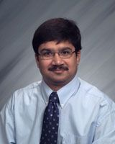
Amit Kumar, Ph.D., P.Eng., is a Professor at the University of Alberta (U of A). He has worked in the area of bioenergy and biofuels for 20 years. His focus has been in biomass supply and logistics and its conversion for the production of energy and fuels. He has made significant contributions in the assessing the environmental and economic footprints of bioenergy systems and is a pioneer in the development of pipeline transport of biomass. He currently holds the NSERC/Cenovus/Alberta Innovates Associate Industrial Research Chair in Energy and Environmental Systems Engineering and the Cenovus Energy Endowed Chair in Environmental Engineering. He also holds Cenovus Energy Endowed Chair in Environmental Engineering. He serves as the Deputy Director of Future Energy Systems, a $75 million initiative at the U of A funded by the Government of Canada through their Canada First Research Excellence Fund. Dr. Kumar has co-authored more than 275 peer-reviewed journal publications, book chapters and technical reports. He has chaired and moderated several sessions at international/national conferences and co-authored more than 420 conference presentations/publications (109 invited). There are 28 media mentions on his research.
Over the last 20 years, Amit has been a strong supporter of CSBE, serving in various roles including regional director (Alberta), Chair and Awards Committee member, and an Associate Editor of Canadian Journal of Bioengineering. He has also helped organize the CSBE Annual General Meeting in Edmonton. Through his leadership, several new engineers have become members of the society. He has trained more than 190 highly qualified personnel. In 2011, Amit was named CSBE Young Engineer of the Year.

Amit has served on expert review panels and steering committees as chair and member including the European Commission, the National Science Foundation (USA), Natural Resources Canada, Natural Sciences and Engineering Research Council of Canada, Environment and Climate Change Canada, and the California Environmental Protection Agency. He has been theme lead/member of 10 international and national research networks.

YOUNG ENGINEER
OF THE YEAR AWARD

This award is given to recognize and encourage outstanding work by younger members of the Society. The award is given to members under 40 years of age. It is given for outstanding contributions to agricultural, food and/or biological engineering through design and development, extension and management, or research and teaching.
The award recipient is selected from nominations by three members of the CSBE/SCGAB and must receive the unanimous consent of the Awards Committee.

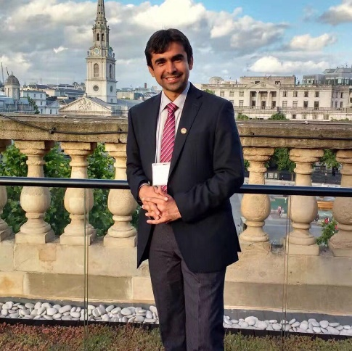
Dr. Aitazaz Farooque is an Associate Professor & Industry Research Chair – Precision Agriculture at the Faculty of Sustainable Design Engineering, University of Prince Edward Island. Based on his student-centered approach to teaching by going above and beyond for students and encouraging students to push the boundaries of their learning, he has been awarded with Dalhousie University Teaching Impact Award 2015. He was also awarded with the Engineers PEI Award for Engineering Excellence 2018 for excellence in the practice of engineering, the teaching of engineering and engineering research. He is also a recipient of the 2019 Presidential Award for Combined Achievement (teaching, research and service) from the University of Prince Edward Island. He is a Professional Engineer and registered in both PEI and Nova Scotia. Dr. Farooque’s research focuses on fundamental understanding and development of state of the art PA technologies for Eastern Canada’s agriculture industry. Development of innovative and novel PA systems utilizes knowledge of engineering design, development and management, instrumentation, design and evaluation of sensors and controllers, development of hardware and software for automation of machines to sense targets in real-time for spot application of agrochemicals on an as-needed basis to improve farm profitability while maintaining environmental sustainability. . Dr. Farooque has developed collaborations nationally and internationally. Dr. Farooque highlighted the significance of his research in peer-reviewed journals, conference proceedings, workshops, industry meetings and farmer’s field days. He is supervising undergraduate and graduate students. He is a Professional Engineer and registered in both PEI and Nova Scotia

JOHN TURNBULL AWARD

Originally, this award was known as the CSAE/Canadian Sheet Steel Building Institute Award. This award is given annually to the CSBE/SCGAB member who, in the opinion of the Awards Committee, has produced outstanding work in the structural field in industry, teaching, research or extension.

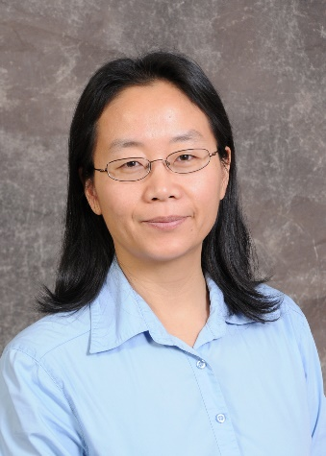
Dr. Huiqing Guo, P.Eng., is awarded the Canadian Society for Bioengineering (CSBE/SCGAB) John Turnbull award for her outstanding contribution to teaching, research and professional service in agricultural building systems engineering. Huiqing has been a Professor at of the University of Saskatchewan since 2002, before 2013 in the Department of Agricultural and Bioresource Engineering, after 2013 in the Department of Mechanical Engineering. She is a Professional Engineer in the Province of Saskatchewan since 2002. She is a twenty-twoyear member of CSBE/SCGAB. She has served on the CSBE/SCGAB Awards Committee since 2004 as member, Vice Chair, Past Chair; she has served as moderators/chair for numerous technical sessions at CSBE/SCGAB annual conferences, coordinated the CSBE/SCGAB President visit to the U of S, and chaired the 2006 CSBE/ASABE Regional Conference Committee. Huiqing is the recipient of one ASABE Superior Paper Award. Huiqing teaches various courses in the area of animal and plant structures and environment and remains very active in research in this area and she has expanded her research area to air quality in environmental engineering. Her research results contribute to the knowledge in the areas of animal production environment, greenhouse environment, and air emission impact assessment for agricultural sources, especially air dispersion modeling and setback determination.

JOHN CLARK AWARD

This award, given in memory of John Clark, is given to the CSBE/SCGAB member who, in the opinion of the Awards Committee, has produced outstanding work in industry, teaching, research or extension in one or more of the fields of Electric Power and Processing, Energy or Food Engineering.

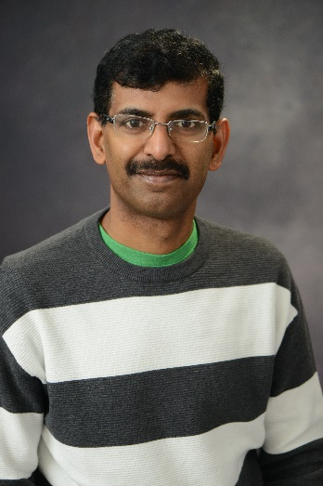
Dr. Manick Annamalai obtained bachelors (Agricultural Engineering) and masters (Food Process Engineering) from the Tamilnadu Agricultural University (India) and PhD (Biosystems Engineering) from the University of Manitoba. Manick has 20 years of experience in academia and food industries. At present, he is an Associate Professor with the School of Engineering at the University of Guelph.

His research activities are in two main streams: 1. Bio-imaging techniques for food safety and quality 2. Processing and product development for health and wellness (whole grains, pulses, and healthy sugar substitute). He has published 63 articles in peer reviewed journals and 17 book chapters, edited 9 books and presented more than 100 conference papers.

He has secured more than 2 million dollars in research grants as a Principal Applicant and Co-Applicant through 21 projects. He has supervised and graduated 12 postgraduate students as a main supervisor. He currently advises or co-advises 10 PhD students. He has been working continuously to develop novel quality assessment tools for wide range of food industries to improve the profitability and food safety.

Apart from scientific research and development, Manick has the passion to communicate the nutrition knowledge to the community. To promote whole grain consumption, improve their availability, and motivate researchers across the world, he established “Whole Grains Research Foundation” in 2015 as a Founder and President. Using this foundation, he has been organizing whole grain conferences and workshops. As Chairman, so far, he has organized 8 international Conferences/Symposium/Workshop on whole grains.

GLENN DOWNING AWARD

This award is presented to the CSBE/SCGAB member who has produced outstanding work in industry, teaching, research or extension in the area of Power and Machinery.

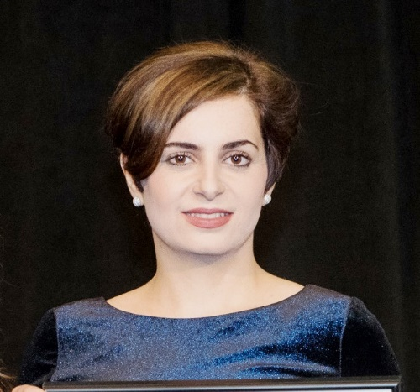
Dr. Fahimeh Yazdan Panah is the recipient of the 2020 Glen Downing Award for her contributions to engineering for biological systems through her research and leadership activities. In addition to her academic and professional qualifications, Fahimeh has demonstrated business acumen, technical expertise, and skills necessary to succeed in all of her endeavors. Fahimeh is currently Research Director for the Wood Pellet Association of Canada and a Research Associate in the Department of Chemical & Biological Engineering, University of British Columbia.

JIM BEAMISH AWARD

The Jim Beamish Award was established in 1989 to honour the memory of the first President of CSBE/SCGAB and a long time worker in Soil and Water Engineering and Water Management. This award is given to the CSBE/SCGAB member who, in the opinion of the Awards Committee, has produced outstanding work in industry, teaching, research and extension in the area of soil and water. The Alumni Committee of Prairie Farm Rehabilitation Administration (PFRA) sponsors the award.

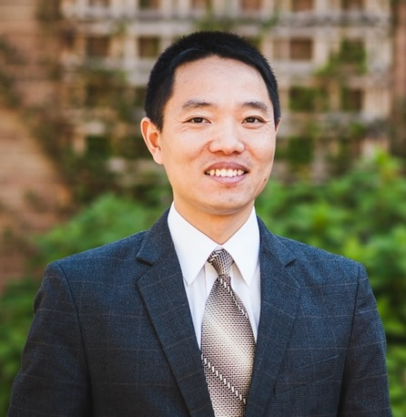
Dr. Zhiming Qi is recognized for his research, teaching and services to his professional engineering societies in the area of soil and water engineering. He has led very strong research programs in modelling the loss of phosphorus from agricultural lands, development of computer models for water quality assessments, and prediction of greenhouse gases from fertilizers and manures. He has published over 65 papers in refereed journals, and has delivered over 60 technical presentations at CSBE, ASABE and CWRA conferences. He has also been invited by Hohai University, China Agricultural University, and Nankai University in China to deliver talks on his research findings. He teaches large undergraduate courses in land development engineering and surveying, and he also attracts large numbers of undergraduate and graduate students to his course in water quality management. Zhiming has so far trained 13 MSc and PhD students and currently supervises 6 graduate students and several visiting scientists. Zhiming has served CSBE and ASABE in many capacities in the soil water technical area, and was the President of the Association of Overseas Chinese Agricultural, Biological and Food Engineers (AOCABFE). Zhiming is a very collegial member of our faculty and collaborates with researchers at McGill, AAFC, China and the US on a range of soil and water engineering topics. Zhiming’s work has social benefits as it seeks to reduce environmental pollution in agriculture, while economically maximizing profits to farmers.

CSBE/SCGAB INDUSTRIAL AWARD

The award, first presented in 2000, is to recognize and honour industries that have produced a distinguished product or service requiring engineering skill, which has contributed significantly to the fields of agriculture, food processing, or other biosystems industry. The basis for selection of the award may include, but not be limited to, the ingenuity, significance and entrepreneurship involved and the contribution to society and to the profession.

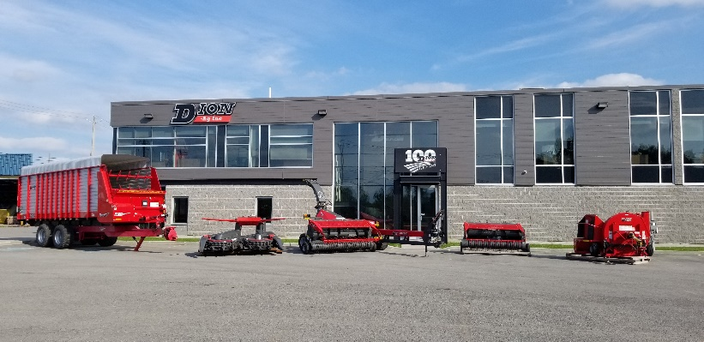
Dion Ag. Inc. is a long standing and well-established company serving farmers in North America and other places worldwide. It provides supply contracts to tens of companies locally, many small business, which specialize in manufacturing or service fields. The company has acquired a flexible and efficient engineering capabilities to efficiently develop high tech products. Its production model is flexible and maintains a strong stable workforce. The company’s business culture promotes leadership, training and skill development of its employees. Future engineers and research projects are regularly supported in the benefit of both the advancement of the company and students.

From the first threshers in 1920 which boosted grain harvester capabilities to the latest Scorpion 350 forage harvester, the most advance pull-type forage harvester in the world, with Isobus controls and stepless hydraulic feed roll drive enabling the use of the full potential and technology available in today’s tractor, Dion Ag. Inc. designs and manufactures products mainly addressed to family farms, helping them be more productive and more profitable. These farms are part of the essential economic and social backbone of rural communities. The company has accompanied them adopting the most recent production methods and systems efficiently.

Through good and harsh times, the Dion brand has succeeded in staying relevant and recognized, reinventing itself over the last 100 years to remain in phase or ahead of the current trends.

CSBE/SCGAB JOHN OGILVIE RESEARCH
INNOVATION AWARD

This new recognition by the CSBE/SCGAB is dedicated for an individual who has made an outstanding contribution to research and has demonstrated professional leadership in any area(s) related to engineering for agriculture and/or bioresource based sector. It is the highest award made by the Society for “research innovation”.
Consideration for this new award will be given for distinguished qualities, society related activities, and professional contributions. His/her research outcome must show evidence of contribution (impact) to the advancement in the areas of scientific application and applied engineering principles for the sustainable production/processing (development) of agri-food, bio-products, and bioenergy systems either in Canada or Internationally.

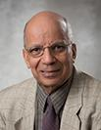
Ramesh Rudra Ph.D., P.Eng. is the recipient of the CSBE/SCGAB John Ogilvie Research Innovation Award for his outstanding contributions to research in soil and water engineering. Dr. Rudra is a professor of Water Resources Engineering at the School of Engineering, University of Guelph. He obtained the B. Sc. in Agricultural Engineering in 1970 from the Punjab Agricultural University (India) and M.S. in Agricultural Engineering in 1976 and Ph.D. in Agricultural Engineering in 1980 from the Pennsylvania State University (USA).

The focus of Dr. Rudra’s research program has been on the development of agricultural nonpoint source pollution control practices for Ontario’s climatic conditions, including mechanics and modelling of processes of drainable water quantity and quality at plot, field, and watershed scale. His contributions include innovative ways of introducing the concept of temporal variations in soil hydraulic and erosion characteristics, targeting approaches for agricultural watershed management, mutli-tier approaches to watershed management, and modelling and monitoring procedures to identify sources of runoff, erosion and pollution from agricultural watersheds.

Ramesh’s research group introduced the application of modelling approaches for agricultural non-point source pollution management during 1980’s and SWAT modeling in the Canadian Great Lakes basin in early 2000. The modelling approaches and the SWAT model are currently used by many conservation authorities in Ontario and many other public and private sectors in Canada. His recent research work has focused on winter hydrology of Ontario, variable source hydrology, effect of climate change on precipitation and temperature regimes, and nutrient management.
Dr. Rudra has supervised over 120 Highly Qualified Personnel (M.Sc, M.Eng., Ph.D. and Post-Doctoral Research Fellows), published more than 200 refereed publications, ten book chapters, one book, and more than 550 presentations at national and international conferences, workshops and symposia. For his exceptional services to CSBE and significant contributions to soil and water engineering field in Canada, Dr. Rudra received the CSBE’s Maple Leaf Award in 2018. He was elected to the grade of Fellow by CSBE in 2005. Ramesh was also made a Fellow of the Indian Society of Agricultural Engineers in 2012.

